THE PRIORY PADDOCK WILDFLOWER GARDEN

The garden was created in 1996 with the boardwalk funded by The Old Millhillian Society in thanks for the years their school was welcomed and accommodated in St Bees during its evacuation to the village in the war years. | 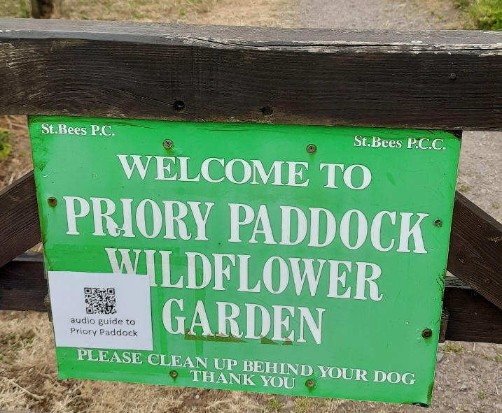
The garden uses an area of wetland on the valley floor to provide an accessible area of biodiversity. The garden boasts over 100 species of flowering plants and is maintained and developed by local volunteers.

A point of particular note is the Monks' Laver - an ancient stone cistern fed with pure water from a natural spring and sympathetically surrounded by modern paving.

Further information may be found at https://stbees.org.uk/home/rest/priory-paddock/

